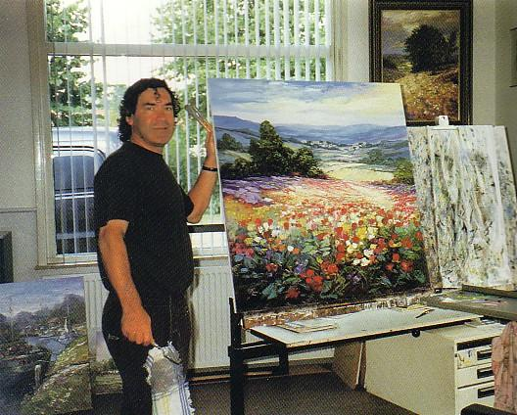

Peter Van Berkel
PETER VAN BERKEL IS AN ARTIST IN THE TRUE SENSE OF THE WORD. HIS PAINTINGS SEEM TO HAVE BEEN
CREATED WITH NATURAL EASE. THIS IMPRESSION OF NATURALNESS THAT RADIATES FROM HIS CANVASES,
HOWEVER, IS MISLEADING. EVERY BRUSH STROKE IS WHERE IT SHOULD BE; THERE IS NO DETAIL THAT COULD
BE LEFT OUT WITHOUT DISTURBING THE HARMONY. THIS IS THE HIDDEN STRENGTH OF HIS WORK.
AT A VERY EARLY AGE, PETER VAN BERKEL (1956, ROTTERDAM) ALREADY KNEW THAT HE WOULD DEVOTE HIMSELF TO PAINTING. HIS TALENT MANIFESTED ITSELF WHEN HE WAS VERY YOUNG AND AT THE AGE OF FOURTEEN, HE DID HIS FIRST OIL PAINTING. HIS HALF-BROTHER, JAN HOVENER, A PAINTER ALSO, TAUGHT HIM THE PRINCIPLES OF PAINTING. PETER DECIDED NOT TO GO TO AN ART SCHOOL, BUT TO PERFECT HIS SKILLS IN PRACTICE. HE STARTED PAINTING PASSIONATELY, BUT HE LEARNED MOST FROM JUST LOOKING AT THE WORLD AROUND HIM. WHEN TRAVELING WITH JAN AND JAN’S FAMILY THROUGH FORMER YUGOSLAVIA, PETER LEARNED MORE ABOUT PAINTING THAN COULD BE TAUGHT IN ANY ART SCHOOL, JUST BY WATCHING HIS BROTHER, WHO PAINTED WHATEVER VIEW OR OBJECT HE LIKED. AT THE AGE OF 18, PETER AND HIS GIRLFRIEND ELLY GEYS LEFT ROTTERDAM FOR WEMELDINGE IN ZEELAND, THEY MOVED INTO A HOUSE IN THE COUNTRY. THE QUIET LIFE IN A LITTLE VILLAGE IN ZEELAND WAS QUITE DIFFERENT FROM THE BIG CITY LIFE OF ROTTERDAM. WHEN HE GOT TO KNOW THE VILLAGERS, PETER LEARNED THAT THERE WERE SEVERAL WELL-KNOWN ARTISTS AMONG THEM. HE WAS INTRODUCED TO LODEWIJK BRUCKMAN, FRANS VAN DER HEIDE,HENNY DE KORTE AND REIN SLEVERS. FRANS VAN DER HEIDE WAS HIS NEIGHBOR AND PETER ACCOMPANIED FRANS ON A TRIP TO SPAIN. ALSO REINS SIEVIERS SUPPORTED THE UP-AND-COMING ARTIST WITH VALUABLE ADVICE. ON HIS VARIOUS TRAVELS ABROAD, PETER VAN BERKEL USED TO SPEND HOURS AND HOURS IN MUSEUMS, STUDYING THE WORK OF THE IMPRESSIONIST MASTERS HE LOVED AND ADMIRED SO MUCH. HIS EFFORTS HAVE PROVED TO BE FRUITFUL. HE HAS NOT ONLY GROWN INTO AN ARTIST OF GREAT EXPERTISE, BUT HE CAN ALSO PRIDE HIMSELF ON A VERY PERSONAL FACTOR.
IN 1976 PETER AND ELLY GOT MARRIED AND TWO YEARS LATER THEIR FIRST CHILD WAS BORN. PETER WAS WORKING ON OYSTER PONDS, MUSSEL FISHING AND AROUND OLD HARBORS THAT TOOK HIS BREATH AWAY. IT WASN’T LONG BEFORE HE TOOK HIS EASEL TO THE HARBOR TO PAINT THE OLD FISHING BOATS AND MUSSEL PROCESSING FACTORIES. AFTER A YEAR HE HAD ENOUGH FOR HIS FIRST EXHIBITION IN THE OLD CITY HALL OF GOES IN DECEMBER 1979. THE EXHIBITION WAS A GREAT SUCCESS AND THE RAVE REVIEWS GAVE HIM THE STRENGTH TO CONTINUE PAINTING, EVEN THOUGH FINANCIALLY LIFE WAS NOT EASY AT THE TIME. GRADUALLY, THE DARK COLORS IN HIS YERSEKE PAINTING GAVE WAY TO LIGHTER TONES. WHEN HE SAW MONET’S WATERLILLIES IN PARIS AND OTHER ART WORKS BY THE IMPRESSIONIST'S, HIS LOVE OF THE COLORS OF THE SCHOOL OF THE HAGUE RECEDED INTO THE BACKGROUND. ON HIS TRAVELS THROUGH FRANCE HE NOTICED THAT A FRANCE LANDSCAPE TURNS OUT TO BE MUCH LIGHTER THAN A DUTCH ONE, A REVELATION THAT WOULD HAVE FAR REACHING CONSEQUENCES FOR THIS ARTISTIC DEVELOPMENT.
Van Berkel is very successful and his paintings are many times sold before they have properly dried. Apart from a number of early exhibitions and the large art fairs in Frankfurt, Germany and the United States, he does not exhibit his work very often as his paintings are predominantly pre-sold.
The paintings of Peter van Berkel are found in galleries throughout the United States, including galleries in DALLAS, TEXAS; Naples, Florida; Washington, D.C.; Chicago, Illinois; Atlanta, Georgia; Danville and Tahoe, California; Charlotte, North Carolina; Pittsburgh, Pennsylvania; and Gross Pointe, Michigan.

